ELEC 344

Lab Experiment: ___

Section: ___

Bench #: ___

Partners | Student ID #: | % participation | Signatures

Date Performed:

Date Submitted:

Table 1: Motor Nameplate Information and Nominal Characteristics
Info/Parameter | Nominal/Rated Value | Comments
NEMA Class
Horse Power
Speed
Number of Poles
Line Current
Line Voltage
Calculations corresponding to full load
Efficiency
Power Factor

How can you explain the voltage and current information? Briefly explain why the motor has two sets of values.

Table 2: Nominal/rated phase voltage and current assuming Y-connected winding
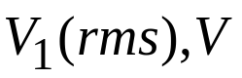 | 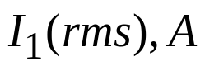
Table 3: Stator winding DC resistance measurement (Do not exceed 5 A dc current!)
 | Measurements (line-to-line) |  | Calculation
Using DC Source | 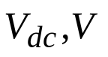 | 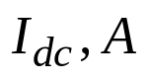 | 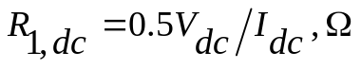
Using Multimeter | 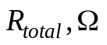 |  | 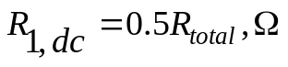
Table 4: No-load measurement (motor is free spinning)
Average phase voltage 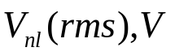 | Average phase current 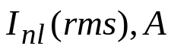 | Average phase power-factor angle 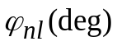 | Total real power 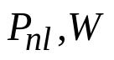 | Calculate rotational losses 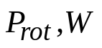
Table 5: Blocked-rotor measurement (motor is not spinning)
Average phase voltage 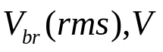 | Average phase current 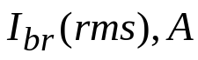 | Average phase power-factor angle 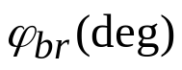 | Total real power 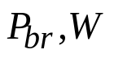 | Stall Torque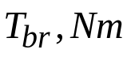
Table 6: Load test measurement: (under nominal voltage, 19 V)
Measurement # | 1 | 2 | 3 |  | 4 | 5 | 6 | 7
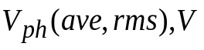keep it constant
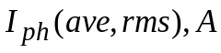
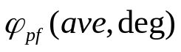
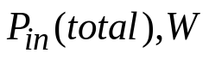
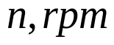
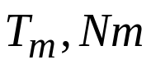
Calculation
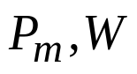
Slip 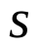
Using last measurement, calculate SR 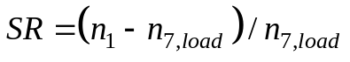
Using last measurement, calculate efficiency of the Motor, % 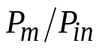
Table 7: Motor speed control by varying voltage (Motor may stall at low voltages)
Measurement # | 1 | 2 |  | 3 | 4 | 5 | 6
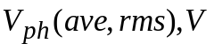
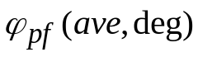
Calculation
Slip
Using last measurement, calculate SR 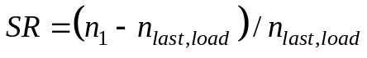
Table 8: Load test measurement: (under low voltage, 12 – 14V)
Measurement # | 1 | 2 | 3 | 4 | 5 | 6 | 7
keep it constant
Calculations
Slip
Table 9: VFD: Motor speed control by varying frequency at Vdc =45 V
Measurement # | 1 |  | 2 |  | 3 |  | 4 | 5 |  | 6
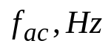 | 10 |  | 20 |  | 40 |  | 60 | 80 |  | 95
Inverter input DC current 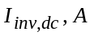
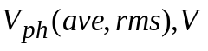
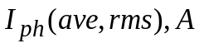
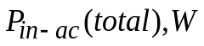
Calculate Slip
Calculate these values corresponding to different frequencies |  | Inverter input power 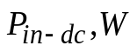 |  | Input power at the Induction Motor terminals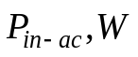 |  | Output mechanical power 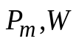 |  |  | Efficiency of the Inverter, % 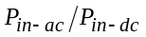 |  | Efficiency of the Motor, % 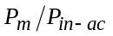
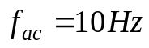
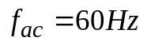
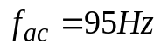
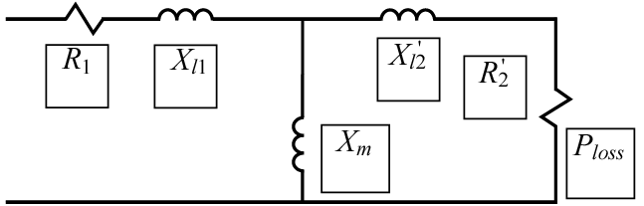

rot

Fig. A. Induction Machine Equivalent Circuit. Fill-in the corresponding boxes with machine parameters that you have determined. Make sure to include the units.

